ANSWERS:

**1) B**

**2) C**

**3) A**

**4) C**

**5) E (angle bisector)**

**6) A**

**7) C**

**8) C**

**9) C**

**10) C**

**11) B**

**12) A**

**13) B**

**14) A**

**15) D**

**16) E (undefined)**

**17) D**

**18) C**

**19) C**

**20) D**

**21) A**

**22) C**

**23) A**

**24) B**

**25) B**

**26) C**

**27) C**

**28) A**

**29) D**

**30) D**

SOLUTIONS:

1. The distance the head of the hammer travels is the sum of the distance traveled in its circular motion before launch and the distance traveled after launch. This is simply $3 revolutions × \frac{3×2π ft}{1 revolution} +6 seconds × \frac{4π ft}{1 second}=42π$. **B**
2. The ground distance Cayle travels is the 3rd side of a triangle with two other sides of lengths of 6 ft and 9 ft. There is also an included angle of 60 $°$. This requires Law of Cosines. ${ground distance}^{2}=6^{2}+9^{2}-2×6×9×\cos{60°}=117-54=63$. $ground distance=\sqrt{63}=3\sqrt{7}$. **C**
3. The volume of a cylinder is $π {× radius}^{2} × height$ and the volume of a hemisphere is $\frac{2}{3} × π × {radius}^{3}$. The volume is . **A**

4) Using the Pythagorean Theorem, you can find that the length of the diagonals of the rectangle is 10. Since the rectangle is inscribed in a circle, each vertex of the rectangle, which is a right angle, intercepts a semicircle. Therefore, the diagonal of the rectangle is a diameter of the circle. The radius of the circle is therefore 5, and the area is therefore. **C**

5) Since the Circumcenter is the intersection of all perpendicular bisectors of the sides of a triangle, the answer would be angle bisector as all three angle bisectors of a triangle intersect at the incenter. **E**

6)The two semicircular ends can be combined to form a complete circle with circumference. The length of the two straight-aways is x.  can be solved to find  **A**

7) *Solution 1:* We will use shoelace formula to solve this. Using the formula, we get $\left[5×1+3×5+\left(-2\right)×\left(-3\right)+\left(-3\right)×\left(-2\right)+5×1-3×1-\left(5\right)×\left(-3\right)-\left(5\right)×\left(-3\right)-\left(-2\right)×\left(5\right)-\left(-2\right)×\left(1\right)\right]÷2=38.$

*Solution 2:* You can separate the figure into two right triangles and one rectangle. The one of the two triangles has vertices at (-2,5), (1,1), and (-2,1). This has an area of 6. Another triangle has its vertices at (5,3), (1,1), and (5,1). This has an area of 4. The rectangle has its vertices at (-2,1), (5,1), (5,-3), and (-2,-3). This has an area of 28. 28+6+4=38. **C**

8) One method: Let line k be perpendicular to y = 2x+5 and intersect y = 2x+5 at its y-intercept. Then, k: . Next, find where this line intersects y=2x+10. Solve, and find that x = -2. Substituting x back into y=2x+10, you find that the point of intersection is (-2, 6). The distance between the two lines is the distance between the y-intercept (0,5) and (-2,6). Using the Distance Formula or Pythagorean Theorem, you can find that this distance is . **C**

9) The surface area of a sphere is . The surface area of a hemisphere is , and since you now have two of them, the new surface area is , which is an increase of 50%. **C**

10) This is a simple ratio problem. 3’ 3” is 39” and 4’ 3” is 51”. 7’ 7” is 91”.

With this in mind: $\frac{39}{51}=\frac{13}{17}=\frac{91}{x}⟹13x=1547⟹x=119"$. 119” is 9’ 11”. **C**

11) The number of diagonals within a convex polygon is calculated by the formula $\frac{n(n-3)}{2}$, where n is the number of sides of the polygon. . **B**

12) The side lengths of the surrounding hexagons of the middle lane are 64 and 68. Their respective perimeters are 384 and 408. $\frac{384+408}{2}=396$. **A**

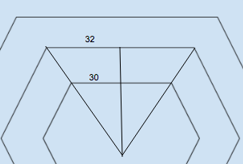13)From the figure shown on the left, one can see that the hexagons consist of equilateral triangles. The distance between the sides of the hexagons is then just the difference of the altitudes of the two equilateral triangles. The smaller equilateral will have a height of $30\sqrt{3}$ and the larger one will have a height of $32\sqrt{3}$. The width is thus $2\sqrt{3}$. Notice how the side lengths of each successive hexagon form an arithmetic sequence. Because the side lengths of each successive hexagon increase at a constant rate, the difference will be the same. That is why the width of every lane is . **B**

14) Using 30-60-90 triangles, the apothem of the innermost hexagon is  while the apothem of the outermost hexagon is . Therefore, the ration simplifies to 5 : 6. **A**

15) The outermost lane is 420 meters and the middle lane is 396 meters. There is a 24-meter difference between the two lanes. Since an average athlete runs at the speed of $6 \frac{meters}{seconds}$, the runner of the outermost lane must be given a $24÷6 second=4 second$ head start. **D**

$16)$ is an undefined value. **E**

17) The sum of the exterior angles of any polygon is $360°$. $\frac{360°}{15°}=24$. This polygon has 24 exterior angles which also means it has 24 sides. **D**

18) Because $∠BAD and ∠ADC$ are same side interior angles, the two angles are supplementary to each other. If $m∠BAD$ =143 $°$, then $m∠ADC$ =37 $°$. The complement of 37 $°$ is $\left(90-37\right)°=53°.$**C**

$19)$ By SSS congruency, triangle APD = triangle BPC. Thus, APD = BPC APD + BPC =360 degrees APB + CPD = 360 – 20 - 80 = 260 degrees and since APD = BPC, APD = ½ x 260 = 130 degrees. Triangle APD is isosceles, so PAD = ½(180-130) = 25 degrees. Triangle APB is isosceles, so PAB = 1/2 (180-20) = 80. So BAD = PAB + PAD = 80 + 25 = 105 degrees. **C**

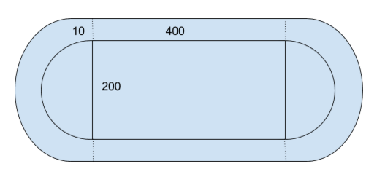20) The area Cynthia can walk can be split into rectangular lanes and circular lanes. The area of the two rectangular lanes are each 4000 ${ft}^{2}$ and the area of both circular lanes is the area of the annulus, which is $\left({110}^{2}-{100}^{2}\right)π=2100π$. The total area is . **D**

21) The volume of a frustum is determined by finding the difference of the volumes of larger cone and the smaller cone. If the height of the smaller cone is x, then the height of the larger cone would be x+12. Since the smaller cone has a radius of 7 and the original one has a radius of 11, using similarities, we obtain the ratio $\frac{x}{7}=\frac{x+12}{11}⟹11x=7x+84⟹4x=84⟹x=21$. The volume of this frustum is . **A**

22) Using the trajectory of the javelin, the ground distance traveled and the height on the javelin at its peak, a 30-60-90 triangle is made. The 50 meters traveled is the hypotenuse, the height is the shorter leg, and the ground distance traveled is the longer leg. The height is 25 meters and the ground distance covered is . **C**

23) The sum of all interior angles of any polygon is equal to $180(\# of sides-2)°$. A pentagon has 5 sides, so this means the sum of all interior angles of a pentagon is . **A**

24) The length of the space diagonal of the rectangular prism determines the maximum distance the shot can travel. The formula for a space diagonal is $\sqrt{a^{2}+b^{2}+c^{2}}$, where *a, b,* and, *c* are sides of the prism. The space diagonal is . **B**

25) **B**

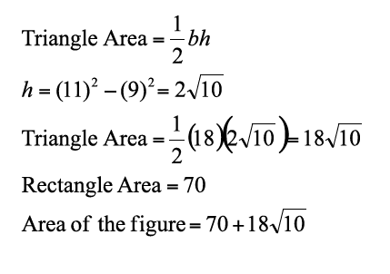

26) If ~q then ~p is the inverse of the converse of if p then 27. **C**

27) If is an angle bisector, then the following relationship holds true: $\frac{\overline{AC}}{\overline{CD}}=\frac{\overline{AB}}{\overline{BD}}$.

This means that $\frac{10}{15}=\frac{7}{\overline{BD}}⟹\overline{BD}=\frac{21}{2}$. **C**

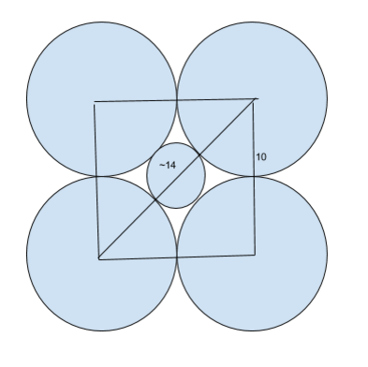28) Boxes of dimensions 40x40 can hold 16 gold medals and 100 silver medals. So it is tempting to claim the answer is $\frac{1600}{16}+\frac{1800}{100}=118$. However, it is possible to slip one silver medal within the cracks of 4 gold medals. The diagram to the right can easily verify this. Because the diagonal of the square is $10\sqrt{2} 14.1$, we know that it can fit a medal with diameter of ~4.1. A box of 16 gold medals can hold 9 silver medals. We need 100 boxes to package 1,600 gold medals so 900 silver medals will then follow. This leaves 900 silver medals, which can be then packaged with 9 boxes. You need at least 109 boxes to package all of the medals. **A**

29) Because the sand pit lost $\frac{1}{2}$ ft of height, $20×3×\frac{1}{2}=30 {ft}^{3}$ of sand was displaced. This means that the volume of block slammed in the sand must also be $30 {ft}^{3}$. $2×2×?=30⟹?=7.5$. The block was 7.5 ft under the sand. **D**

30) The surface area of a cone is the base area added by the lateral area. The base is $9π$ and the lateral area is $circumference×lateral height÷2=6π×5÷2=15π$. Total area is $24π$. **D**